In, Anthony

12/11/2023 10:12 AM

max you got a min for a call

In, Anthony

12/11/2023 10:28 AM

let me call you back in a min

12/11/2023 10:29 AM

Meindl, Max

yep, back from my break/walkabout...

Tuesday, January 16

1/16 6:58 AM

Meindl, Max

water pipes frozen, no heat in office but other than that all is good

MEINDL-DILO-WILO - 01-12-2024.pdf

In, Anthony

1/22 10:57 AM

Max who is your SOR at TIRO?

1/22 10:59 AM

Meindl, Max

1/22 10:59 AM

your SOR from TIRO

1/22 11:00 AM

Meindl, Max

Mark was my primary contact for everything, him or Rick Malbrough

In, Anthony

1/22 11:00 AM

Got it, thanks

1/22 11:02 AM

Meindl, Max

You show up everywhere in the FEMA functions, DTS, FedHR, OER

1/22 11:02 AM

Meindl, Max

as my supervisor

In, Anthony

1/22 11:03 AM

yes going forward. Need just need to know who it was prior to me.

1/22 11:03 AM

Meindl, Max

just a bit with Rick Cain, for some reporting stuff

1/22 11:03 AM

Meindl, Max

Mark and Rick

In, Anthony

1/22 11:03 AM

mark retired. so it is Rick M

1/22 11:04 AM

Meindl, Max

yes he was processing things until the new slot

Hey Max are you a C/E by In, Anthony

In, Anthony

1/24 1:35 PM

Hey Max are you a C/E

1/24 1:35 PM

Meindl, Max

1/24 1:35 PM

Meindl, Max

coach evaluator?

1/24 1:35 PM

Meindl, Max

In, Anthony

1/24 1:36 PM

yes. Thank you

1/24 1:36 PM

Meindl, Max

No problem 🙂

In, Anthony

1/24 1:42 PM

how are things going. Are you working with the cost out team

1/24 1:42 PM

Meindl, Max

working two projects now

1/24 1:42 PM

Meindl, Max

going well..

In, Anthony

1/24 1:42 PM

Great to hear

1/24 1:43 PM

Meindl, Max

appreciate your support boss... ☮️

In, Anthony

1/29 10:34 AM

Max, you got a min for a call

1/29 10:36 AM

Meindl, Max

yes

In, Anthony

1/29 10:51 AM

give a min on a call now

1/29 10:51 AM

Meindl, Max

call when you can, in the 308

In, Anthony

1/29 11:10 AM

ok you ready

Monday, February 5

max got a min by In, Anthony

In, Anthony

2/5 9:18 AM

max got a min

2/5 9:20 AM

Meindl, Max

yes sir

In, Anthony

2/5 12:48 PM

Got a min

yes by Meindl, Max

2/5 12:59 PM

Meindl, Max

yes

2/29 2:41 PM

Meindl, Max

MEINDL-2024-Mandatory Training Scorecard.pdf

Message by Meindl, Max, has an attachment.

2/29 2:47 PM

Meindl, Max

MEINDL-TRANSCRIPT AllMyTraining-02-29-2024.pdf

EMI by Meindl, Max, has an attachment.

2/29 2:49 PM

Meindl, Max

EMI

Unoffical-Student-Transcript-0000459741--09-26-2023-R1.pdf

Tuesday, March 19

Hey Max, How are you doing? Do you need any... by In, Anthony

In, Anthony

3/19 1:06 PM

3/19 1:11 PM

**Meindl, Max**

**Chipping away Tony, how are you doing? No new updates on my end, still in limbo land and apologies for putting a kink in your team.. I do feel bad about that..**

In, Anthony

3/19 1:12 PM

**yea. no worries. just keep doing what you can with the close out team.**

3/19 1:14 PM

Meindl, Max

thanks Tony, much appreciated.

3/19 1:15 PM

Meindl, Max

heading back to the doctor in the next couple of weeks, see what's changing, if anything, bloodwork, etc. ahh.. the joy of senior time...

In, Anthony

3/19 1:16 PM

ok buddy. hope all good news.

3/19 1:17 PM

Meindl, Max

Thanks

Thursday, March 21

3/21 6:54 AM

Meindl, Max

Tony, I requested off tomorrow, DHS-S1 Hours-Memorial Day 2023, things to take care of.

Wednesday, April 3

In, Anthony

4/3 9:41 AM

max got a min

4/3 9:58 AM

Meindl, Max

YES

Monday, April 8

In, Anthony

4/8 9:06 AM

Morning Max, I need you to go to FEDHR and sign your performance goals. and also I have completed with your 1st QTR eval in FEDHR need you to review and sign that as well. Let me know once you have it complete. Thanks.

Tuesday, April 9

4/9 8:51 AM

Meindl, Max

fyi, sick leave-family, in system, daughter having surgery next week, may not require all 3 days but we'll see.

In, Anthony

4/9 8:52 AM

Ok, thanks for the heads up

By The Way, no work in my que. by Meindl, Max

GM Max

**Morning T, would be great to have some work to do... just saying**. Hoping all is well with you and yours. Should be interesting moving forward, daughter moves home later today, with 2 cats to add to one dog and one cat.. hoping her healing will go well... **anyway... any identified path forward?** and thanks for everything Tony, I really appreciate it.

At this time please continue to work with the Close Out team.

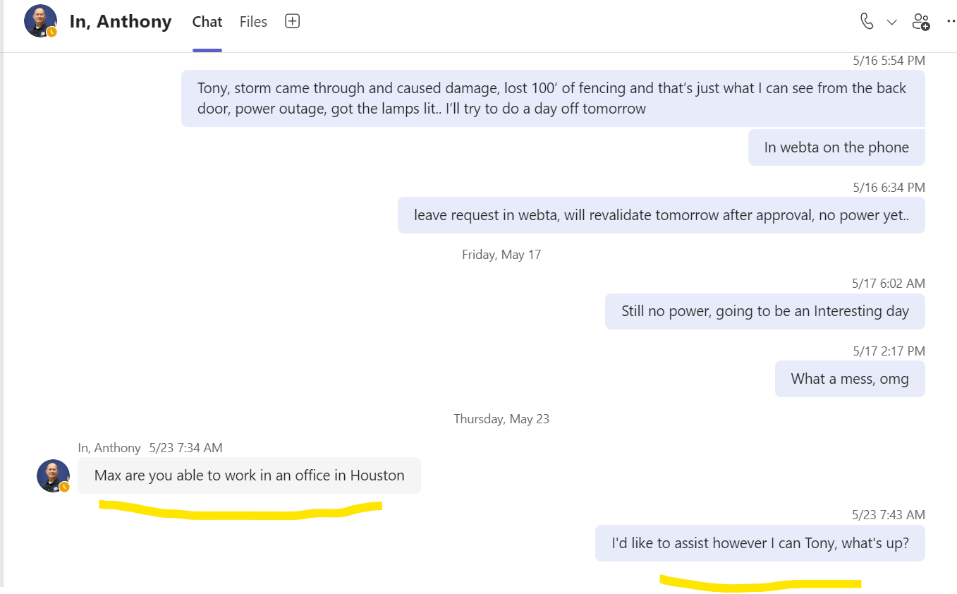

6/27 10:30 AM

Meindl, Max

I'll be doing some training classes for the time being.

Monday, July 8

7/8 6:46 AM

Meindl, Max

☕ ☮️ rain and wind hitting us.. should be an interesting few days..

7/8 7:05 AM

Meindl, Max

call sometime today for a quick chat, when you can.

7/8 7:15 AM

Meindl, Max

if it's headed to College station it goes right over us... hearing transformers cook-off and big limbs down in our yard already..

7/8 8:15 AM

Meindl, Max

may be loosing part of the garage roof soon..

7/8 8:42 AM

Meindl, Max

Power lines down in our area per Austin County Emergency Management, we still have power, a genset and solar backup but we may get kicked off line if things keep failing in the area.. FYI

7/8 9:05 AM

Meindl, Max

Lost power

intermittent power now.. by Meindl, Max

7/8 9:12 AM

Had to restart my computer over a dozen tim... by Meindl, Max

7/8 9:42 AM

Meindl, Max

Had to restart my computer over a dozen times , keep losing power

Thanks Max. I been busy with meetings by In, Anthony

In, Anthony

7/8 9:50 AM

Thanks Max. I been busy with meetings

can you talk while I have power? by Meindl, Max

7/8 9:52 AM

**7/8 10:13 AM**

**Meindl, Max**

**if you are able to deploy me, keep it close for the initial time to see how things go here at home, then we can go out further..**

7/9 6:33 AM

Meindl, Max

☕ 3"-4" limbs down everywhere, 3 windows blown out, fence down.. other than that .. all is good..

**7/9 8:00 AM**

**Meindl, Max**

**so this year... an ice storm, a tornado and a hurricane... darn dude.. owning a house brings its own excitement...**

**7/9 10:02 AM**

**Meindl, Max**

**It is very hard to understand why you aren't allowed to deploy me when the need is stipulated by the FEMA Administrator.. I.E. You Are Needed More Than Ever. None of this is making any sense Tony, just saying.**

**7/9 10:44 AM**

**Meindl, Max**

**It takes all of us to deliver our mission effectively, and I thank you for being willing to deploy when needed. Together, we will rise to the challenges this season may bring. Sincerely, Deanne**

**7/9 10:52 AM**

**Meindl, Max**

**but, if I can assist closeout with some actual work, I'm all in.. FEMA flexible.**

**In, Anthony**

**7/9 12:58 PM**

**Thanks Max, i have talked to Region and waiting for further guidance.**

7/10 6:32 AM

Edited

Meindl, Max

and also lost 1 plum and one apple tree.... darn..

Thursday, July 11

In, Anthony

7/22 9:56 AM

Sorry Max. I was out for the last week. hope everything good on your end.

In, Anthony

7/22 10:05 AM

Siting at the airport waiting for flignt back to Arkansas

7/22 10:09 AM

Meindl, Max

hoping you had a great time off, lost over half of my watermelon crop to coyotes.. they apparently love watermelon. have a docs appt. at 03:30 today so should get some updated info, we'll see, this getting old stuff sucks.. still many repairs to be made after the storms here.. other than that all is well..

In, Anthony

7/22 10:11 AM

I understand. I had a family emergency so I had to run home.

7/22 10:13 AM

Meindl, Max

hoping all is ok...

In, Anthony

7/22 10:16 AM

all good. thanks for asking

7/23 6:53 AM

Meindl, Max

never got in to see the doc yesterday, rescheduled for 10 this morning, putting in for a few hours off for the appt. today.

7/23 7:11 AM

Meindl, Max

waited for over an hour before giving up...

7/23 8:51 AM

Meindl, Max

taking off until noon, docs appt.

7/23 11:25 AM

Meindl, Max

pin cushion is back.... just saying..

In, Anthony

7/25 10:10 AM

Morning Max, I have completed your FEDHR 2nd QTR review. Please review and sign for me. Let me know when you have it complete. Thanks.

7/25 10:35 AM

Meindl, Max

I'm having issues signing, it doesn't do anything when I click "E-sign"

8/5 9:37 AM

Meindl, Max

Can I use you as a recent reference for a job I'm interviewing for this Friday?

In, Anthony

8/5 9:47 AM

Absolutely you can